**StudentCourseAPI Project architecture Documentation**

1. **StudentCourseCore ( class library : models )**
2. **StudentCourseData ( class library : Dapper ->Data layer or Repo layer)**
3. **StudentCourseWebApi: Controllers and Service layer**

**Part 1**

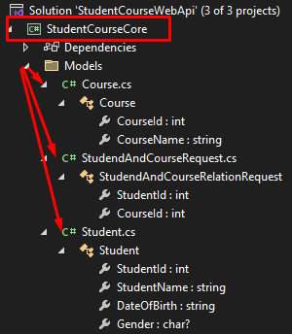

**Part 2 Data layer**

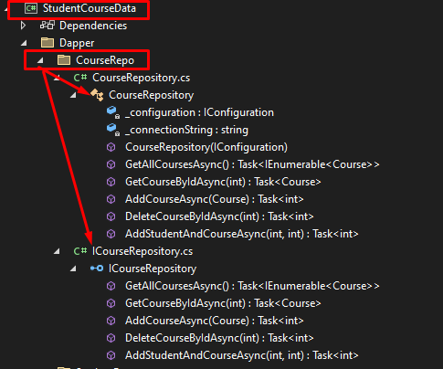

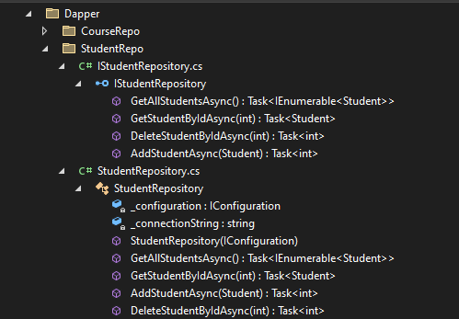

Part 3 WebApi with service layer.

